Practical No. 3
Aim: Perform the following:
A.Write a program to implement one way Operation.
B.Write a program to implement two way Operation.
Code:
Steps:
1. Right click on Java DB and then click on Start Server to start the server .
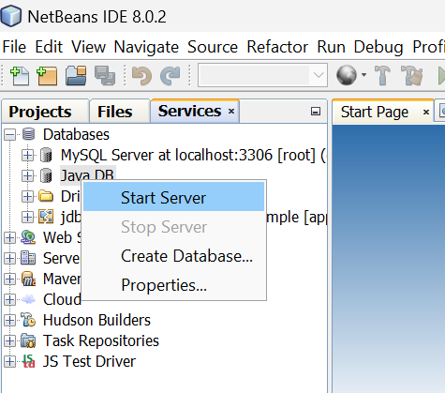
2.Right click and then click on connect to connect the sample database with server.
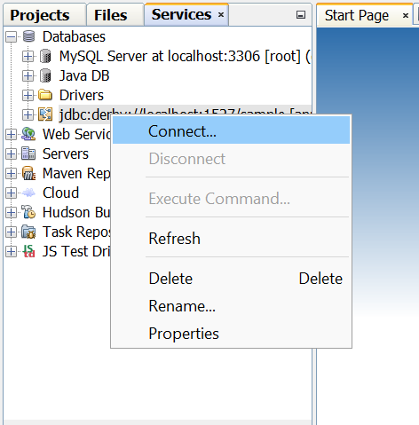
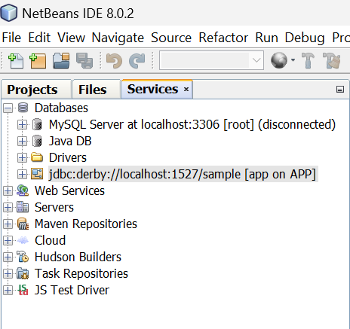
3. Now we are going to create a table in default database sample. Right click on Table -> Create Table
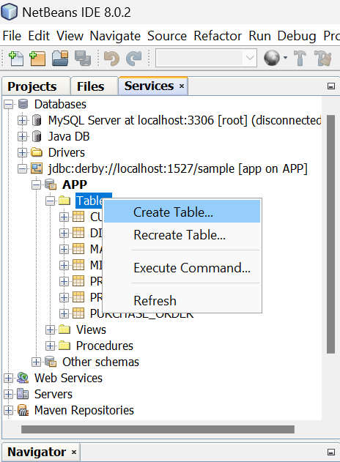
4.Give table name as “friends”.
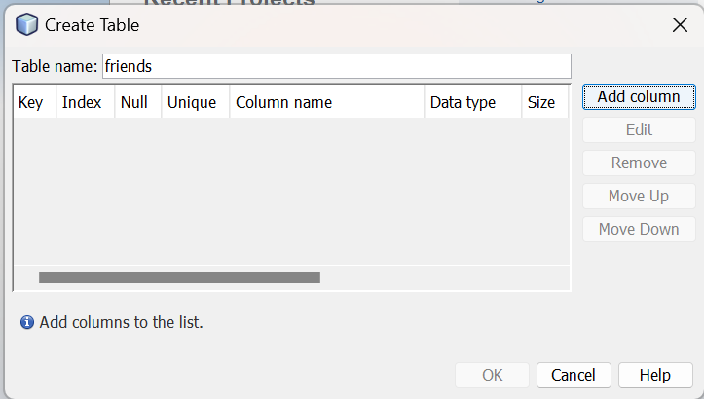
5.Now click on Add column button to add columns in table. Enter details as in below pic and select Primary key. After that click on OK button.
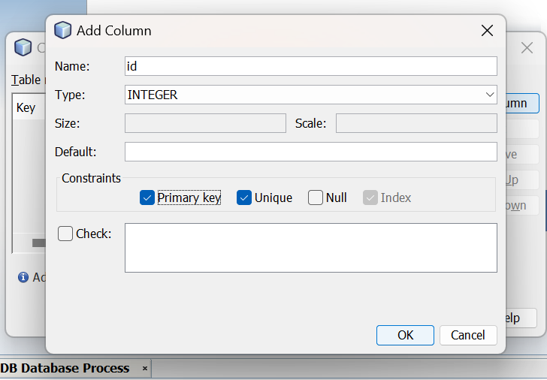
6.Now add second column with following detail. But don’t select primary and click on OK button.
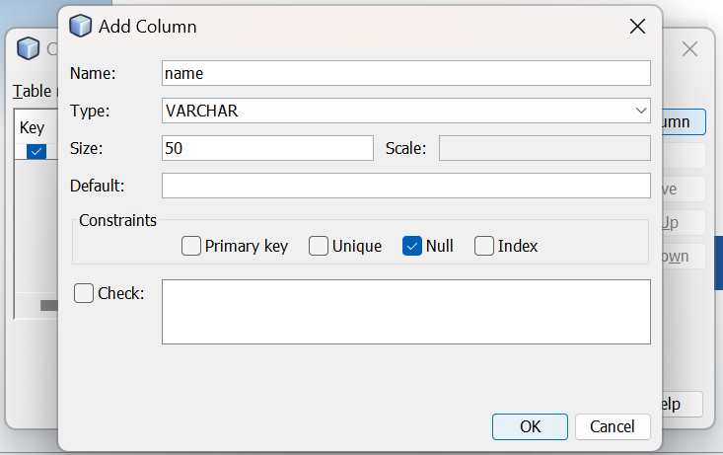
7.Now click on OK button.
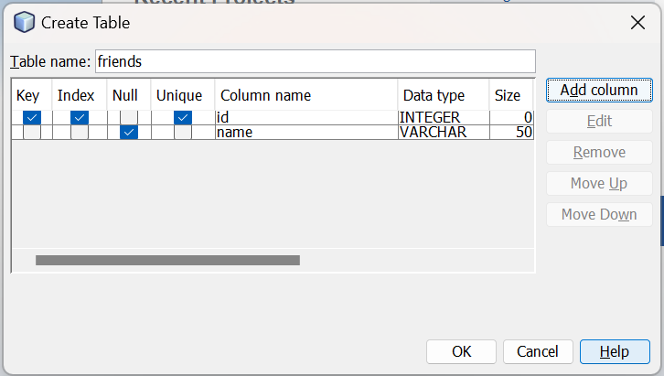
8.Now create a web application with name Service. After that click on Next and then Finish button.
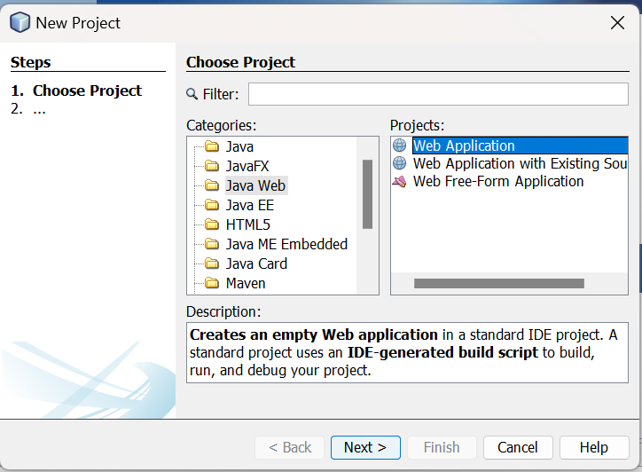
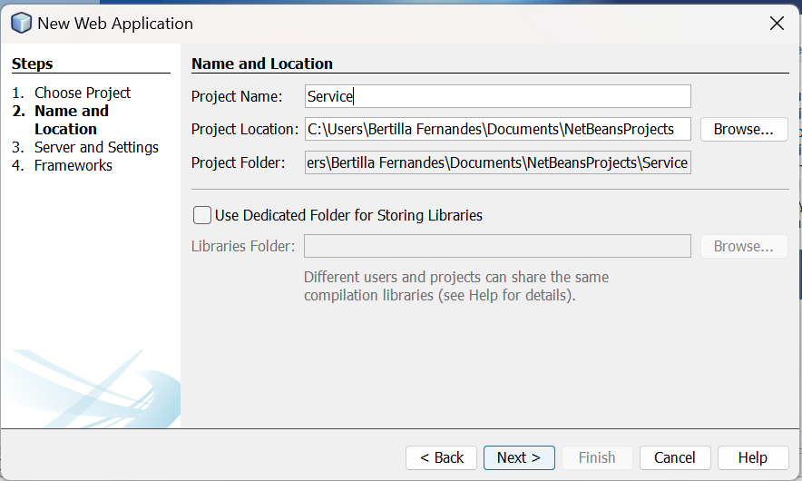
9.Now create a Web Service.
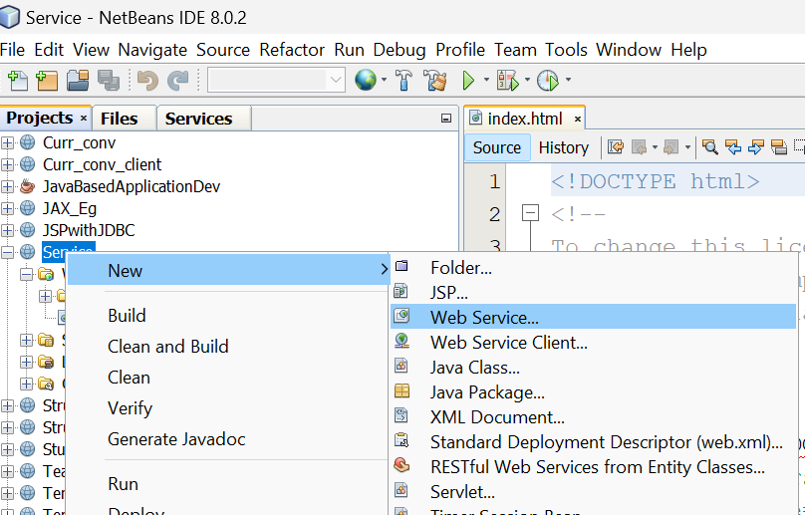
10.Give the webservice the name as “myws” and package name as “ws”
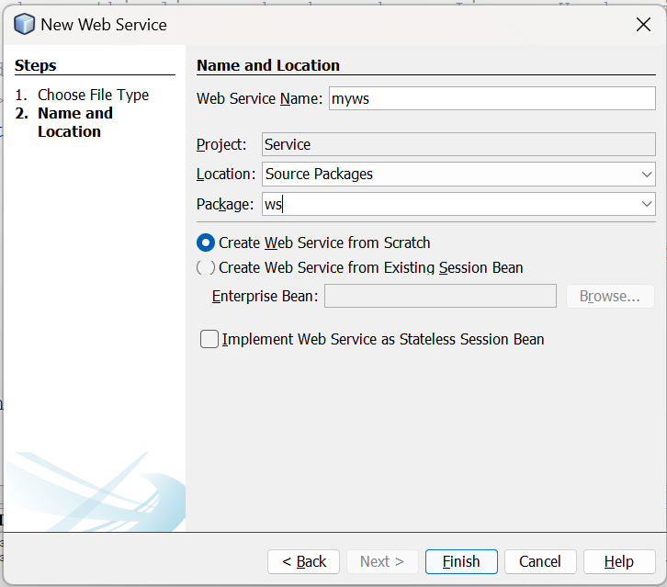
11.Now create the GlassFish JDBC Connection Pool settings as shown below:
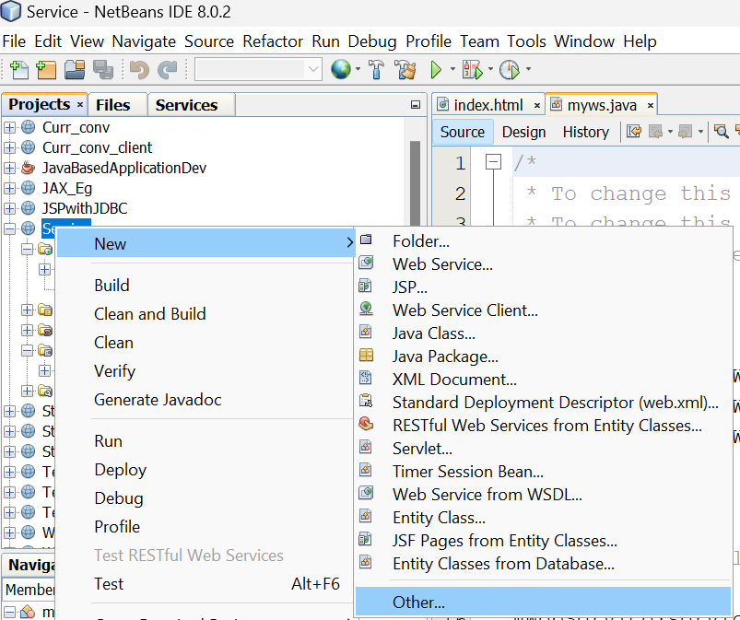
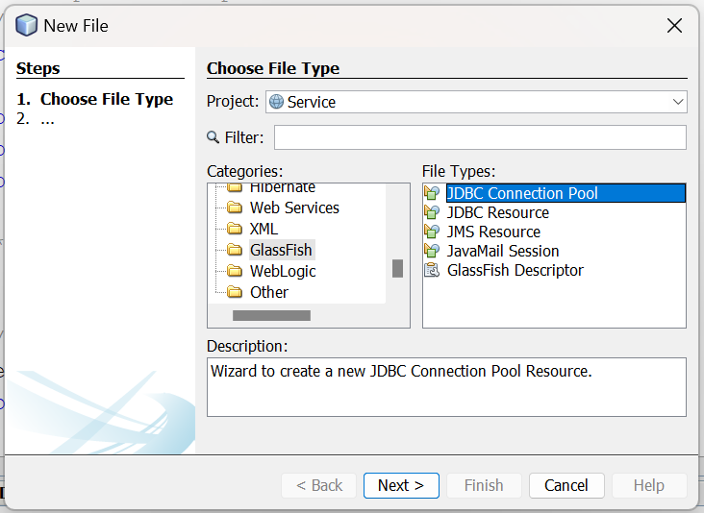
12.Click on next
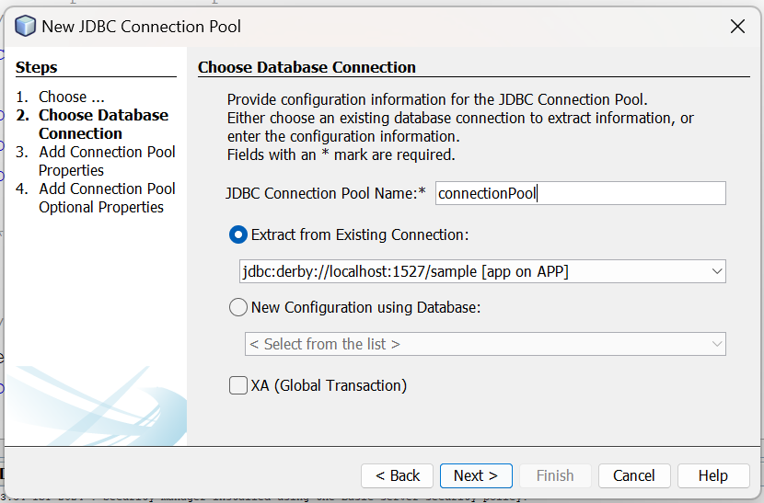
13.Click on next
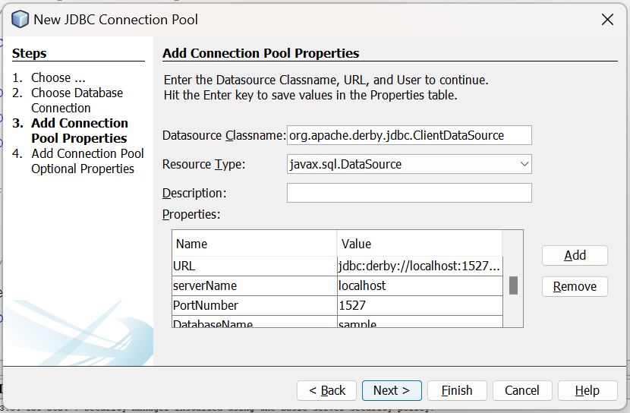
14.Click on next
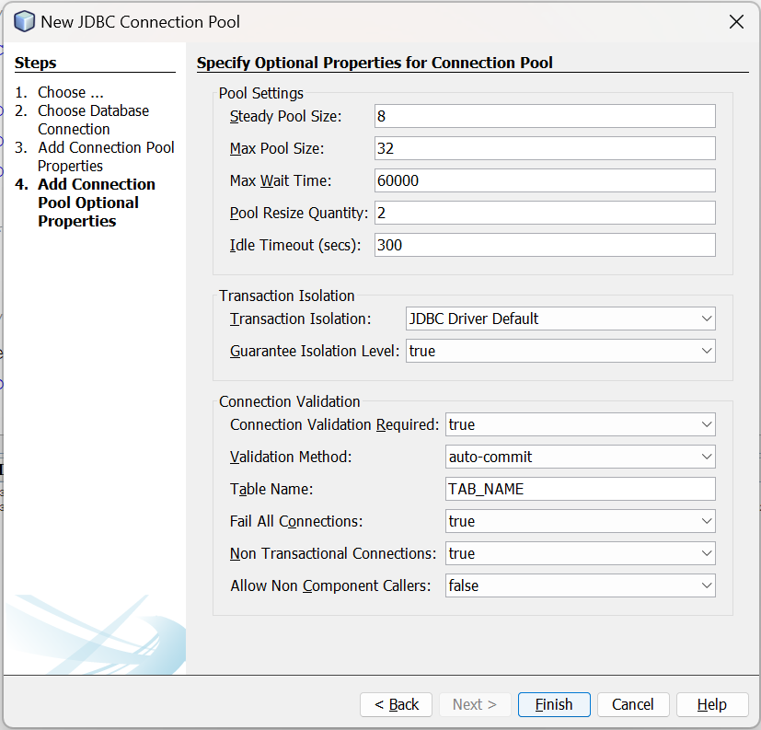
Then click on Finish.

15.Now add the GlassFish JDBC Resource as shown below:
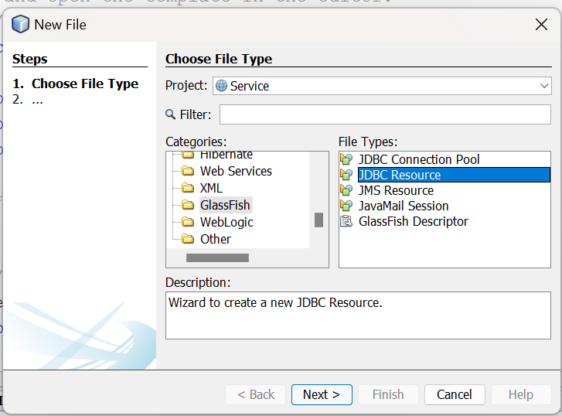
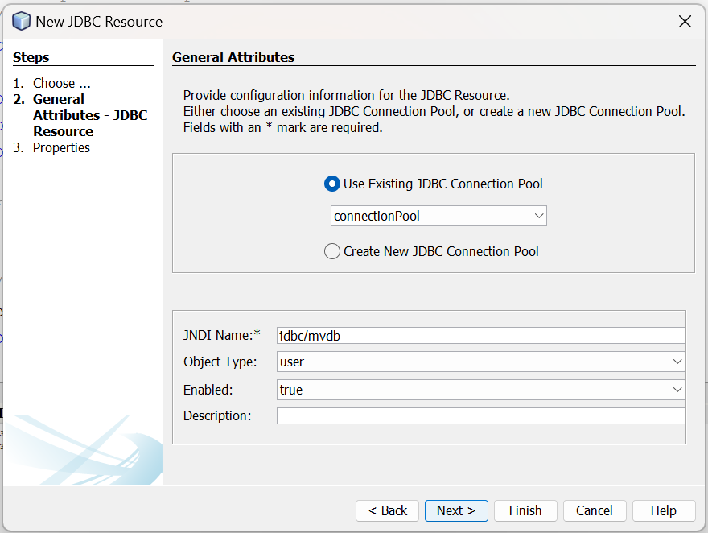
Click on Next
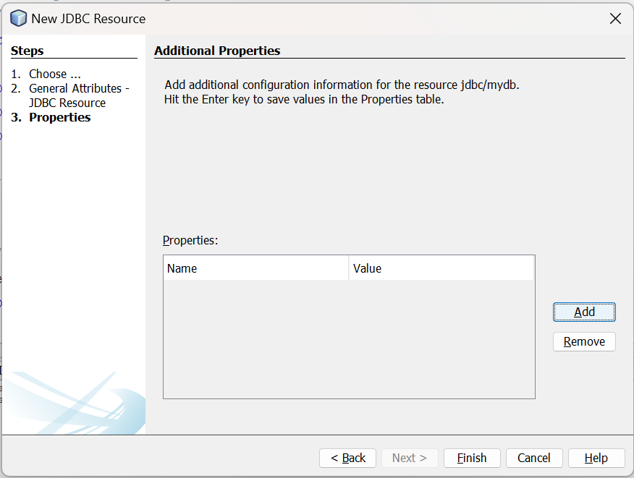
Then Click on Finish.

16. Now add the following setting and code to the myws.java file.
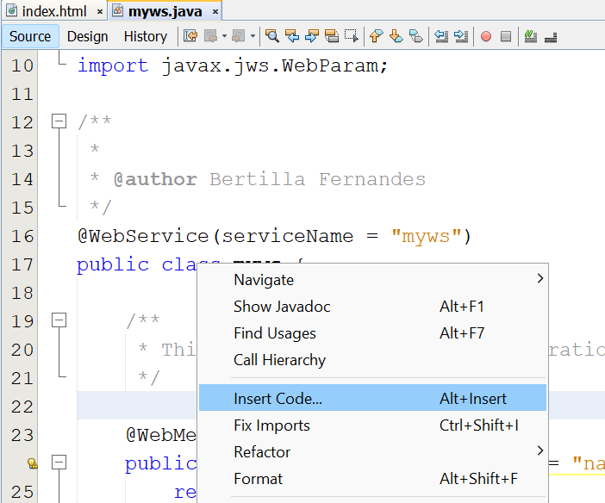
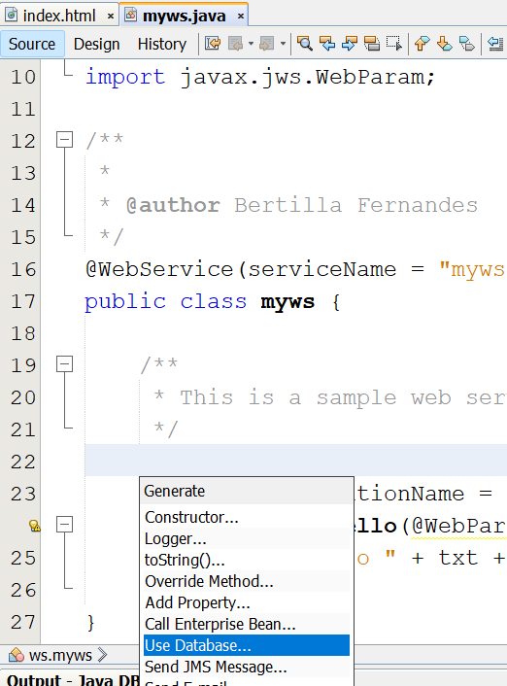
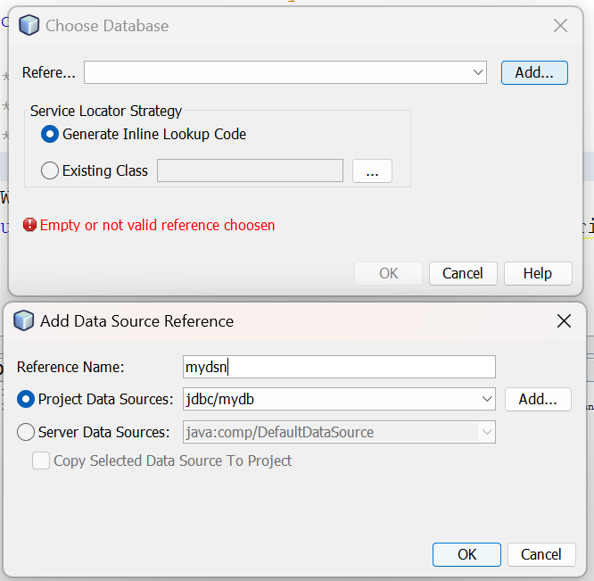
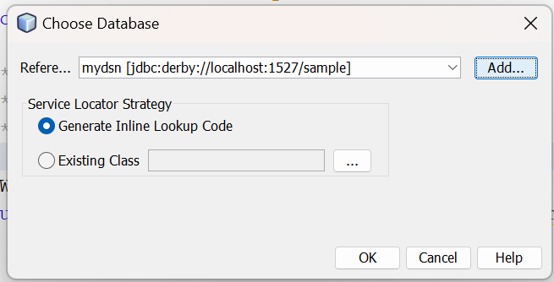
Click on OK.
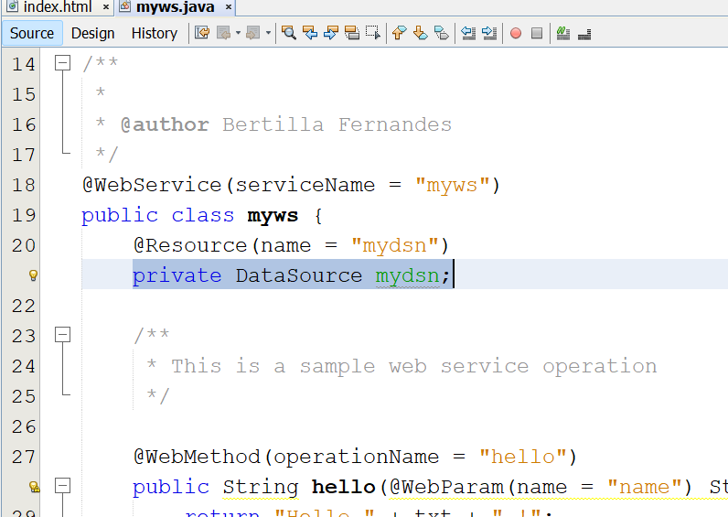

17.Add the following operations:
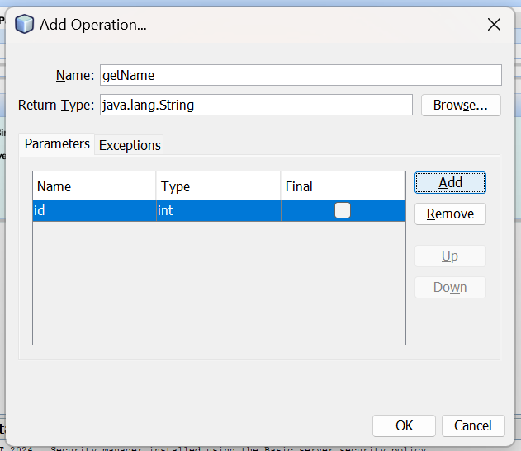
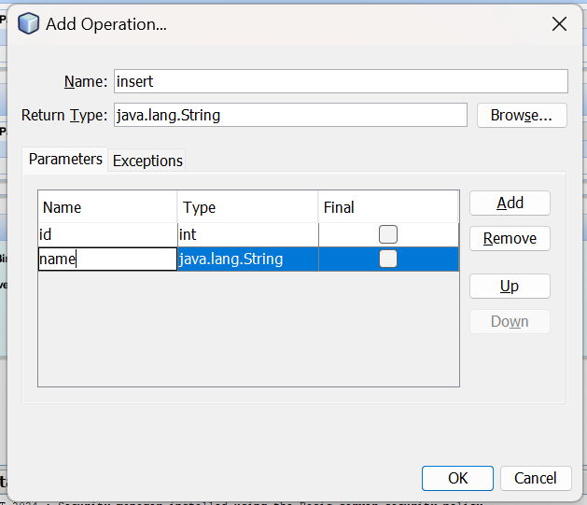

myws.java
/*
* To change this license header, choose License Headers in Project Properties.
* To change this template file, choose Tools | Templates
* and open the template in the editor.
*/
package ws;

import javax.annotation.Resource;
import javax.jws.WebService;
import javax.jws.WebMethod;
import javax.jws.WebParam;
import javax.sql.DataSource;
import java.sql.*;
/**
*
* @author Bertilla Fernandes
*/
@WebService(serviceName = "myws")
public class myws {
@Resource(name = "mydsn")
private DataSource mydsn;

/**
* Web service operation
*/
@WebMethod(operationName = "getName")
public String getName(@WebParam(name = "id") int id) {
try{
Connection c=mydsn.getConnection();
PreparedStatement ps=c.prepareStatement("select * from friends where id=?");
ps.setInt(1, id);
ResultSet r=ps.executeQuery();
if(r.next())
return r.getString(2);
else
return "No name found";
}catch(Exception e)
{return "error";}

}

/**
* Web service operation
*/
@WebMethod(operationName = "insert")
public String insert(@WebParam(name = "id") int id, @WebParam(name = "name") String name) {
try{
Connection c=mydsn.getConnection();
PreparedStatement ps=c.prepareStatement("insert into friends (id,name)values(?,?)");
ps.setInt(1, id);
ps.setString(2, name);
ps.executeUpdate();

}catch(Exception e){}
return null;
}
}

18.Deploy the project.
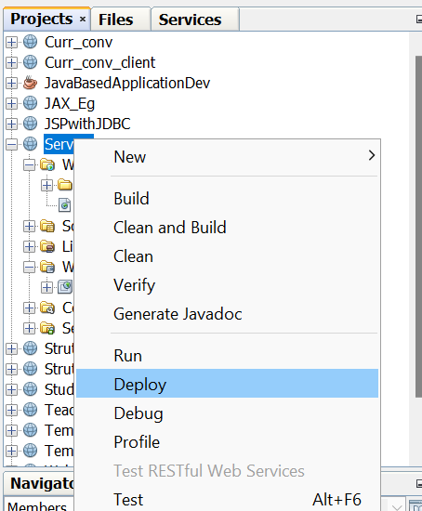

19.Create the Service Client
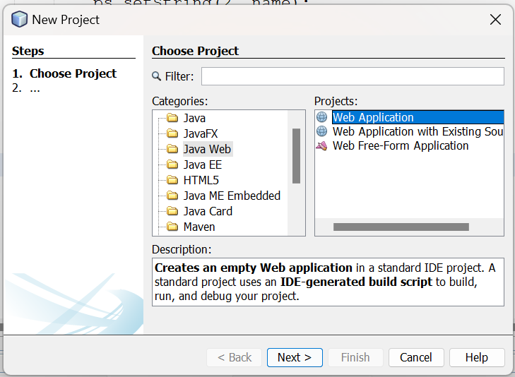
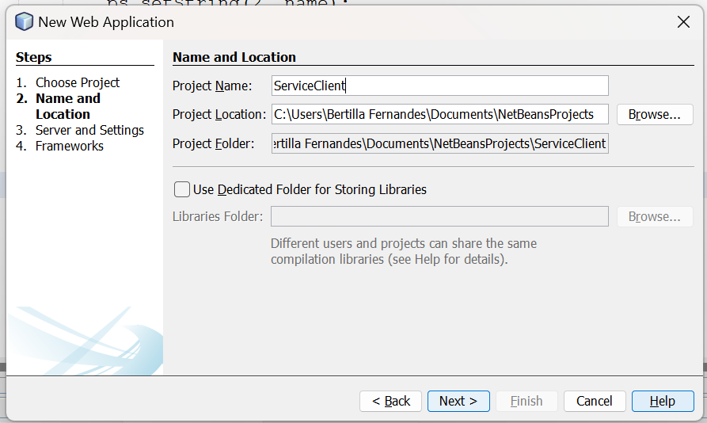
20.Now create the Web Service Client
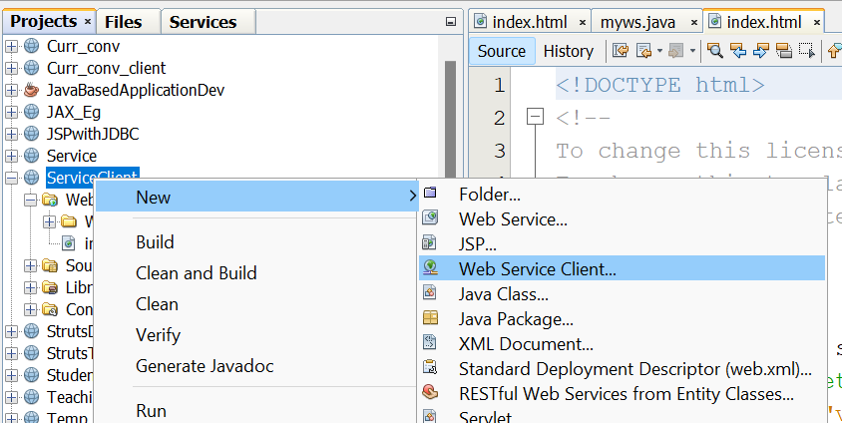
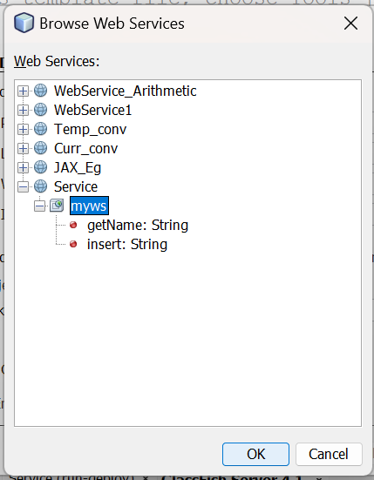
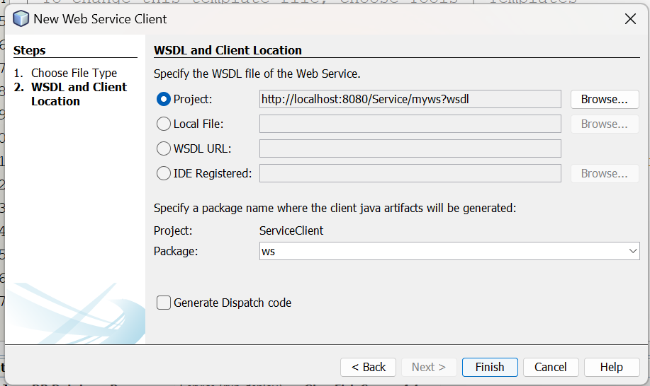
21.Create the JSP files getData and insertData and add the following codes
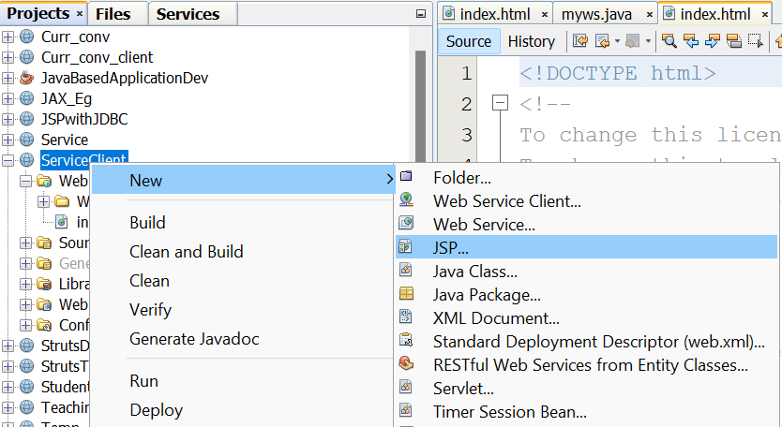
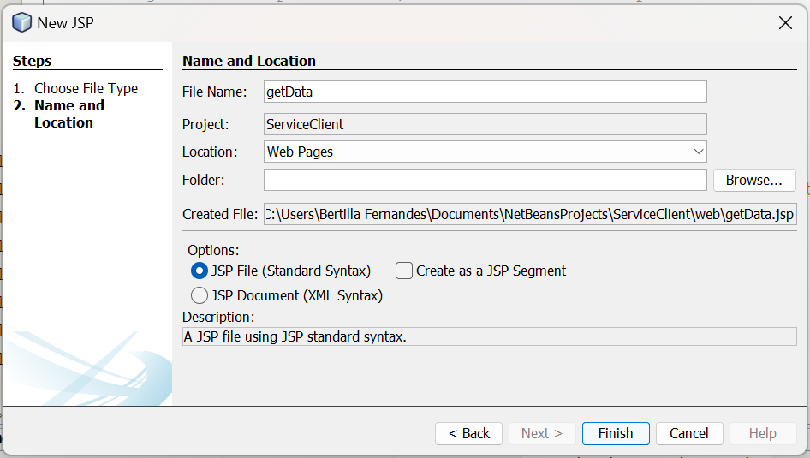

getData.jsp
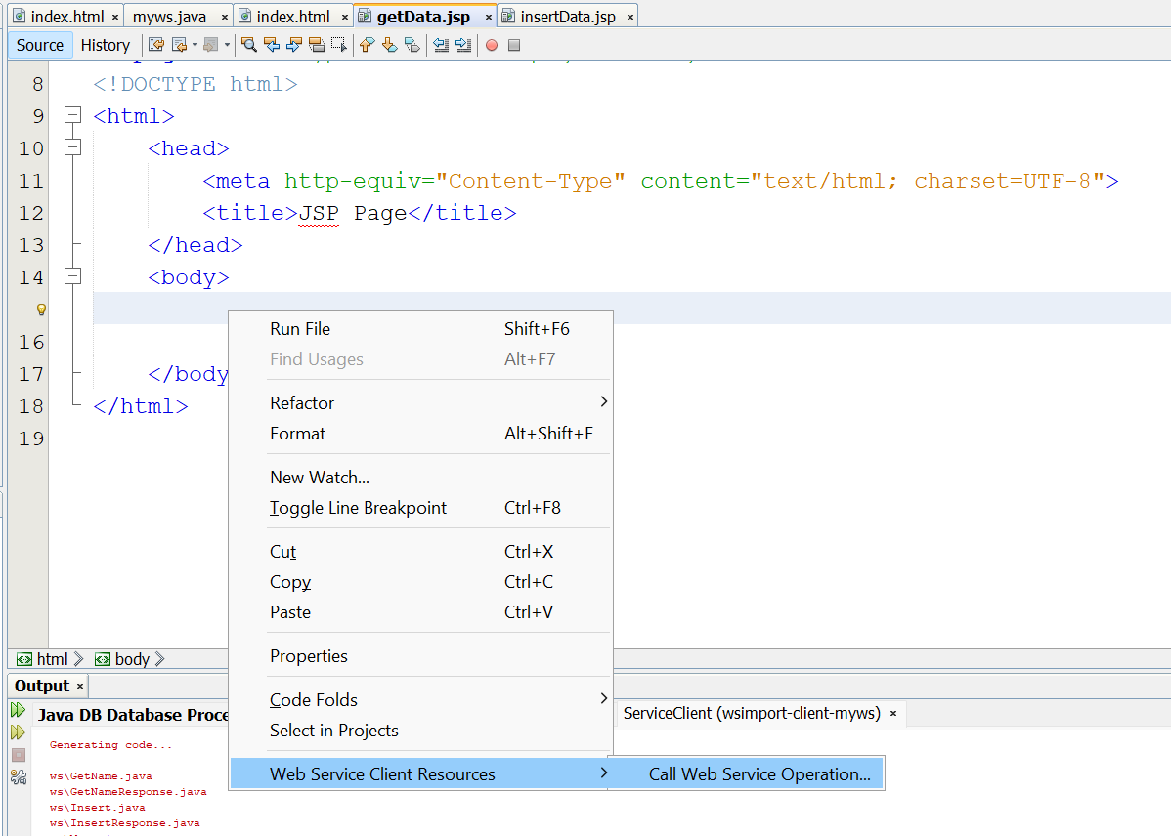
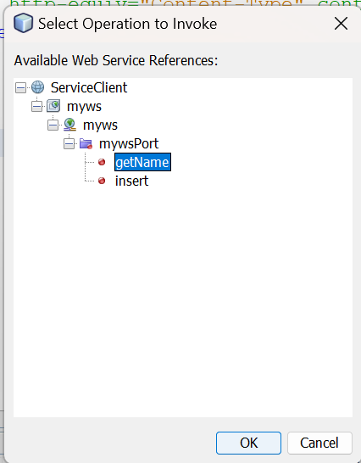
getData.jsp

<%--
Document : getData
Created on : 23 Jul, 2024, 12:04:40 AM
Author : Bertilla Fernandes
--%>

<%@page contentType="text/html" pageEncoding="UTF-8"%>
<!DOCTYPE html>
<html>
<head>
<meta http-equiv="Content-Type" content="text/html; charset=UTF-8">
<title>JSP Page</title>
</head>
<body>

<%-- start web service invocation --%><hr/>
<%
int id=Integer.parseInt(request.getParameter("txt3"));

try {
ws.Myws_Service service = new ws.Myws_Service();
ws.Myws port = service.getMywsPort();
// TODO initialize WS operation arguments here

// TODO process result here
java.lang.String result = port.getName(id);
out.println("Result = "+result);
} catch (Exception ex) {
// TODO handle custom exceptions here
}
%>
<%-- end web service invocation --%><hr/>
</body>
</html>
22. Create another JSP file:
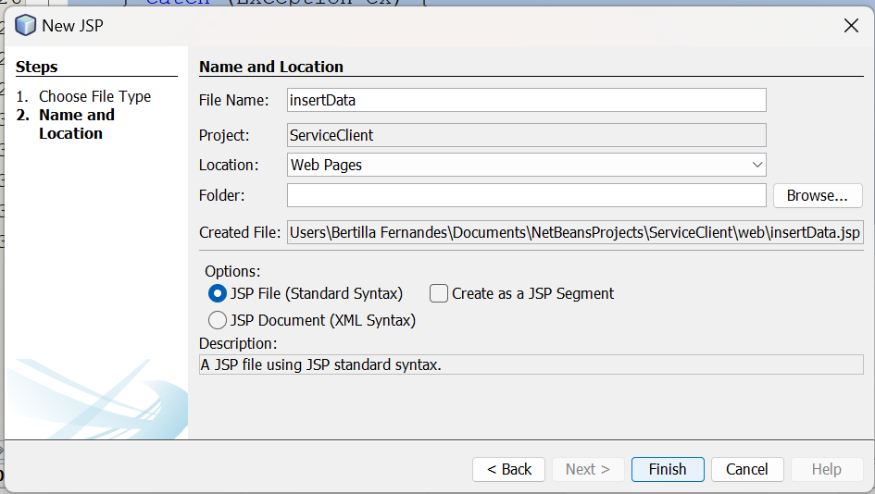

insertData.jsp
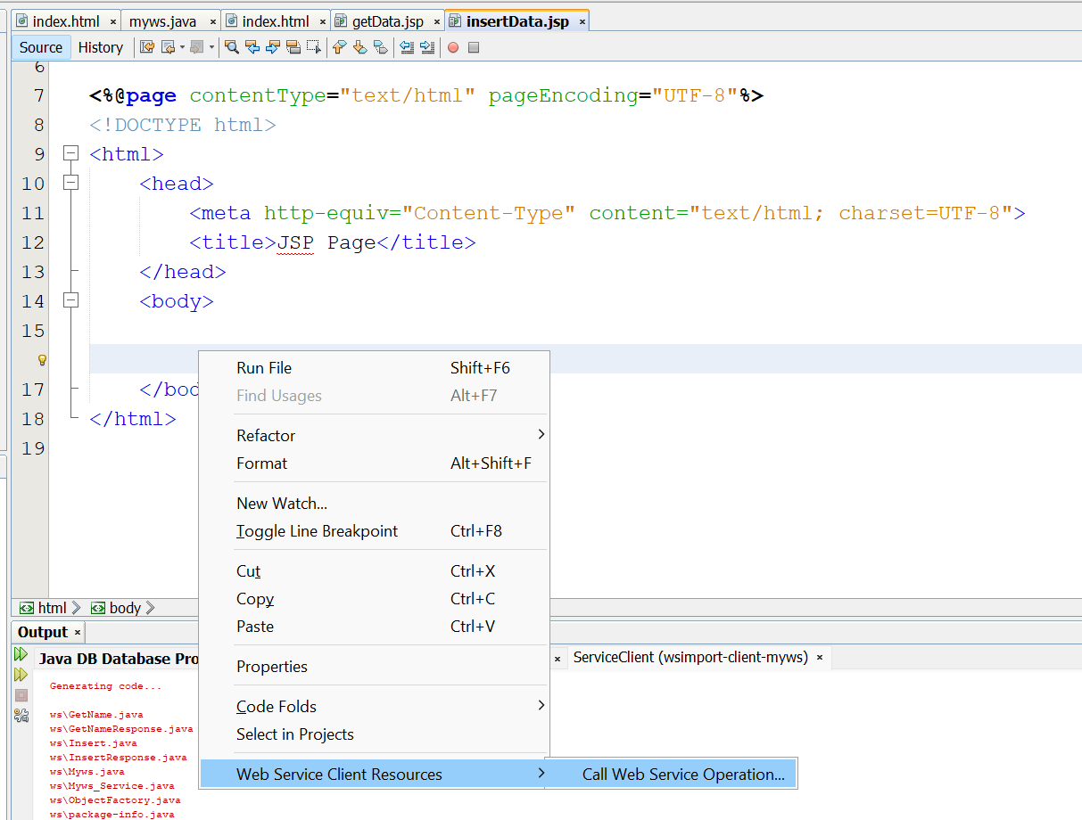
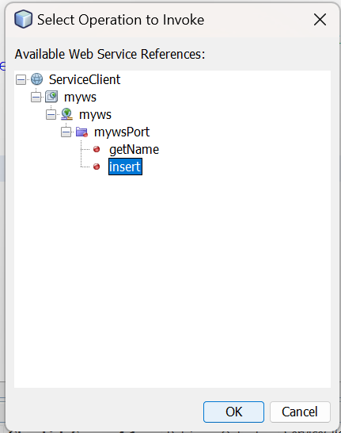
insertData.jsp
<%--
Document : insertData
Created on : 23 Jul, 2024, 12:07:01 AM
Author : Bertilla Fernandes
--%>

<%@page contentType="text/html" pageEncoding="UTF-8"%>
<!DOCTYPE html>
<html>
<head>
<meta http-equiv="Content-Type" content="text/html; charset=UTF-8">
<title>JSP Page</title>
</head>
<body>

<%-- start web service invocation --%><hr/>
<%
int id=Integer.parseInt(request.getParameter("txt1"));
String name=request.getParameter("txt2");

try {
ws.Myws_Service service = new ws.Myws_Service();
ws.Myws port = service.getMywsPort();
// TODO initialize WS operation arguments here

// TODO process result here
port.insert(id, name);
out.println("Data Inserted");
} catch (Exception ex) {
// TODO handle custom exceptions here
}
%>
<%-- end web service invocation --%><hr/>
</body>
</html>
23.Create the index.html file and add the following code.
(Service Client)
index.html file
<!DOCTYPE html>
<!--
To change this license header, choose License Headers in Project Properties.
To change this template file, choose Tools | Templates
and open the template in the editor.
-->
<html>
<head>
<title>TODO supply a title</title>
<meta charset="UTF-8">
<meta name="viewport" content="width=device-width, initial-scale=1.0">
</head>
<body>
<form>
<h2>One way operation</h2>
<input type="text" name="txt1" placeholder="EnterId"><br>
<input type="text" name="txt2" placeholder="EnterName"><br>
<input type="submit" formaction="insertData.jsp" value="insert"><br>
<h1>----------------------------------</h1>
<h2> Request -Response operation </h2>
<input type="text" name="txt3" placeholder="EnterId"><br>
<input type="submit" formaction="getData.jsp" value="GET DATA"><br>
</form>

</body>
</html>

24.Deploy the Project
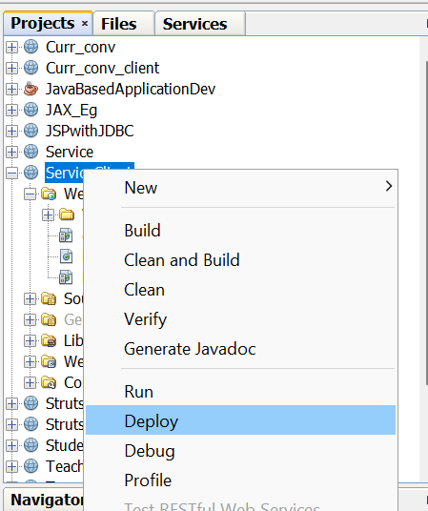

25.Right click on “friends” to view and add records into it.
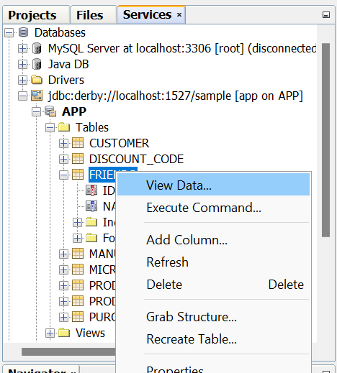
26.Now click on the leftmost icon in second panel to insert some record.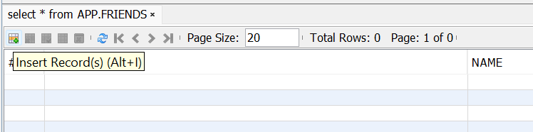
27.Insert a record and then click on Add Row button to insert more record. After that click on OK button to finish.
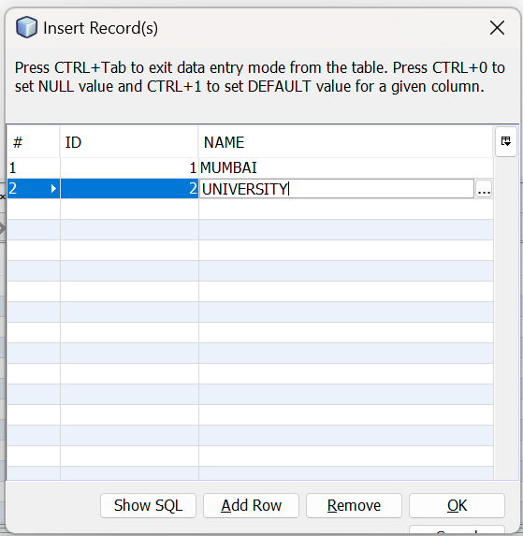
28.Run the project
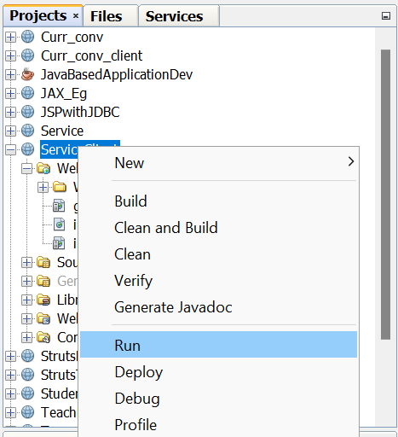
Output:

